Geolocation

- Create a policy in the Policy Wizard and add a Geo-fencing item:
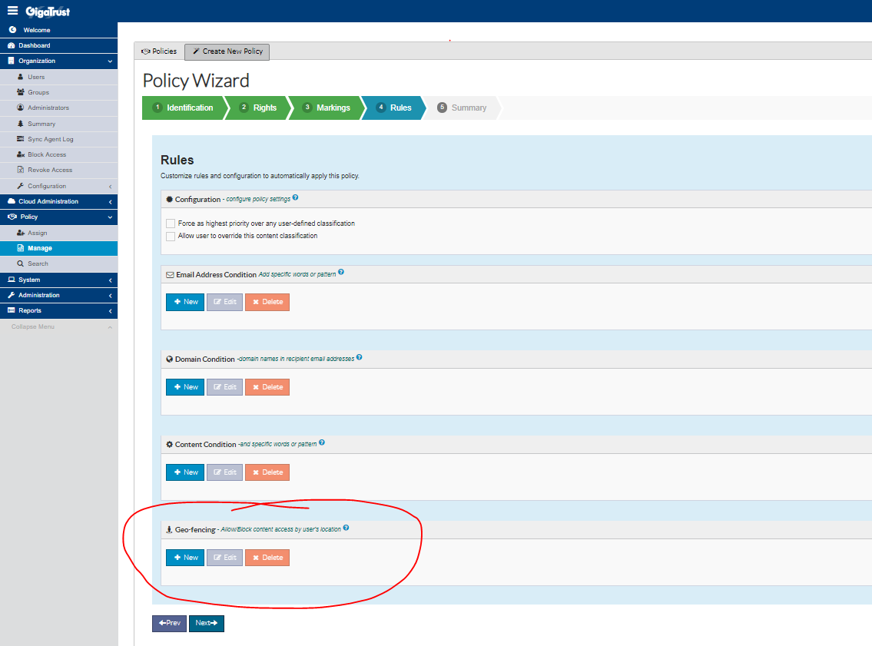
- Clicking on New opens a modal which includes:

  - Select Bounding Box: Country/State

    - Choose from pre-canned Country/State bounding box entries from SQL table: GeoFencingBounding [Dropdown]

  - OR Bullseye: Lat/Long location with radius in meters.

    - Choose (pin on Google Map) or enter Lat/Long in text boxes.

    - Choose from 1, 2, 3, 4, 5, 10, 20, 30, 40 , 50, 100, 500, 1000, 5K (radius) [Slider Control]

    - Dynamically resize pin (puck) from slider on interactive map.

  - Allow/Block [Switch] {bool: True/False}

  - Allow Override (from registry static Lat/Long) [Switch] {bool: True/False}

Note: Applies to all users assigned to this policy.

Note: Saved to Geofencing SQL table with foreign key constraint TemplateID.

- Protect content with policy and send to recipient.

- Recipient tries to consume content with GTDC:

  - GTDC tries to get Geo-location info about client.

    - If available through existing Windows DLLs it reports to endpoint SendGeolocation in Policy.asmx based on returned reporting Interval (default 60000ms) (OverrideSW = false)

    - If unavailable, GTDC uses Override Lat/Long from registry (OverrideSW = true)

  - GTDC attempts to get EUL:

    - In GTEP Server uses logic to see if user has access to content or not and whether or not to provide an EUL:

      - Call is made to get the Geofencing item.

        - If overridden and OverrideAllowedSW is false in Policy, false is returned.

        - Else Lat/Log are ran through algorithm in Geofencing.cs to ascertain if the user is allowed/blocked for the location if a match is found in the Geofencing item. Multiple items are analyzed one-at-a-time. First failure from the collection fails the call and false is returned. If all items pass then True is returned.

      - If false is returned then an Overwatch Event is logged for a Geo-fencing Violation (from the server, to the server.) In addition, a Blocked Access Event is logged for GigaTrust RMS. The EUL is denied to GTDC and the User is denied access to the content. Another (default) Overwatch Event is logged for Failed Access. (Or we add a new Overwatch Event for Blocked Access.)

        - Reverse Geo-location is called to Google Maps API to get additional info to insert with entry in the GTEP DB [Overwatch3] table.

      - If true is returned then the content EUL is made available and an Overwatch Event is created for Open (regardless of Geofencing being enabled for policy.)

        - When Overwatch Event is received on GTEP, Reverse Geo-location is called to Google Maps API to get additional info to insert with entry in the GTEP DB [Overwatch3] table.

- Dashboard UI job picks up the Geo-fencing Violation and pins the location with User/Document information on a map overlay (with pretty graphics/styling from Chuck.)
Pros
- Very little changes to GTDC except for GEO-location support and logging more comprehensive Overwatch Event.

- Uses existing Allow/Block functionality to Geo-fence content in GTEP from the Modules project.

- Piggybacks on current policy to Geo-fence. No additional XML needed in the Template definition.
Cons
- Need to add library for Bounding.

- Need to pay for GoogleMaps API: $4.00 per 100,000 calls per month.

- May still be circumvented for “nefarious” purposes.

